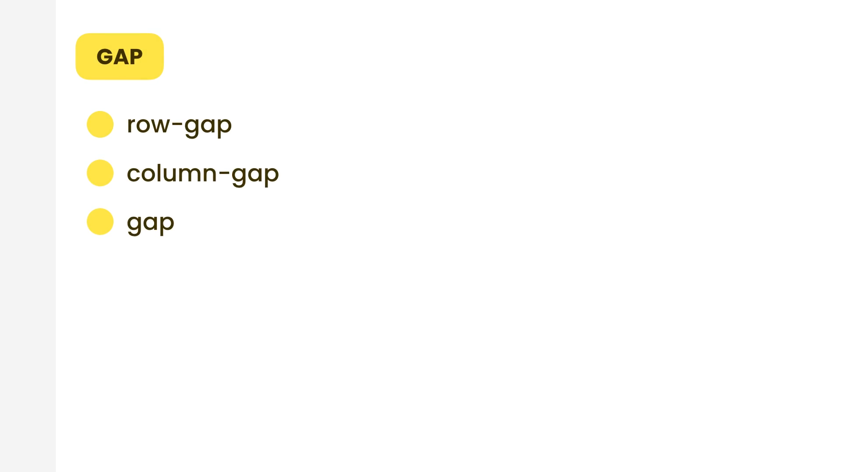

gap: <row-gap>/<column-gap>;

|  |  |
| --- | --- |
| Class | Properties |
| gap-0 | gap: 0px; |
| gap-px | gap: 1px; |
| gap-0.5 | gap: 0.125rem; /* 2px */ |
| gap-1 | gap: 0.25rem; /* 4px */ |
| gap-1.5 | gap: 0.375rem; /* 6px */ |
| gap-2 | gap: 0.5rem; /* 8px */ |
| gap-2.5 | gap: 0.625rem; /* 10px */ |
| gap-3 | gap: 0.75rem; /* 12px */ |
| gap-3.5 | gap: 0.875rem; /* 14px */ |
| gap-4 | gap: 1rem; /* 16px */ |
| gap-5 | gap: 1.25rem; /* 20px */ |
| gap-6 | gap: 1.5rem; /* 24px */ |
| gap-7 | gap: 1.75rem; /* 28px */ |
| gap-8 | gap: 2rem; /* 32px */ |
| gap-9 | gap: 2.25rem; /* 36px */ |
| gap-10 | gap: 2.5rem; /* 40px */ |
| gap-11 | gap: 2.75rem; /* 44px */ |
| gap-12 | gap: 3rem; /* 48px */ |
| gap-14 | gap: 3.5rem; /* 56px */ |
| gap-16 | gap: 4rem; /* 64px */ |
| gap-20 | gap: 5rem; /* 80px */ |
| gap-24 | gap: 6rem; /* 96px */ |
| gap-28 | gap: 7rem; /* 112px */ |
| gap-32 | gap: 8rem; /* 128px */ |
| gap-36 | gap: 9rem; /* 144px */ |
| gap-40 | gap: 10rem; /* 160px */ |
| gap-44 | gap: 11rem; /* 176px */ |
| gap-48 | gap: 12rem; /* 192px */ |
| gap-52 | gap: 13rem; /* 208px */ |
| gap-56 | gap: 14rem; /* 224px */ |
| gap-60 | gap: 15rem; /* 240px */ |
| gap-64 | gap: 16rem; /* 256px */ |
| gap-72 | gap: 18rem; /* 288px */ |
| gap-80 | gap: 20rem; /* 320px */ |
| gap-96 | gap: 24rem; /* 384px */ |

gap-x-*: row gap

gap-y-*: col gap